
FTC & Me
Presented by:
Jennifer Sheehan BSMS, CFSP, CCO

Friday, May 2, 2025 1:00 p.m. – 2:00 p.m. (1 CE)
- Welcome and introductions and ice breaker.
- Recent FTC activity.
- Established fines.
- What is a triggering event?
- What is on your General Price List (GPL)?
- Required disclosures.
- Required items on your GPL. What if I do not offer an item?
- Quiz time!
- What is next?
- Conclusion and Q&A
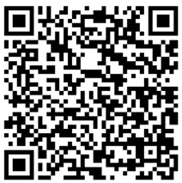
Don’t forget to complete your exit survey
to get your 1 CE!

